CASE STUDY – ONLINE BANKING SYSTEM(PYSPARK)

[Jobaoushadancse2021@gmail.com](mailto:Jobaoushadancse2021@gmail.com)

Job Aoushadan N

1.

number of loans in each category

number of people who have taken more than 1 lack loan

number of people with income greater than 60000 rupees

number of people with 2 or more returned cheques and income less than 50000

number of people with 2 or more returned cheques and are single

number of people with expenditure over 50000 a month

number of members who are eligible for credit card

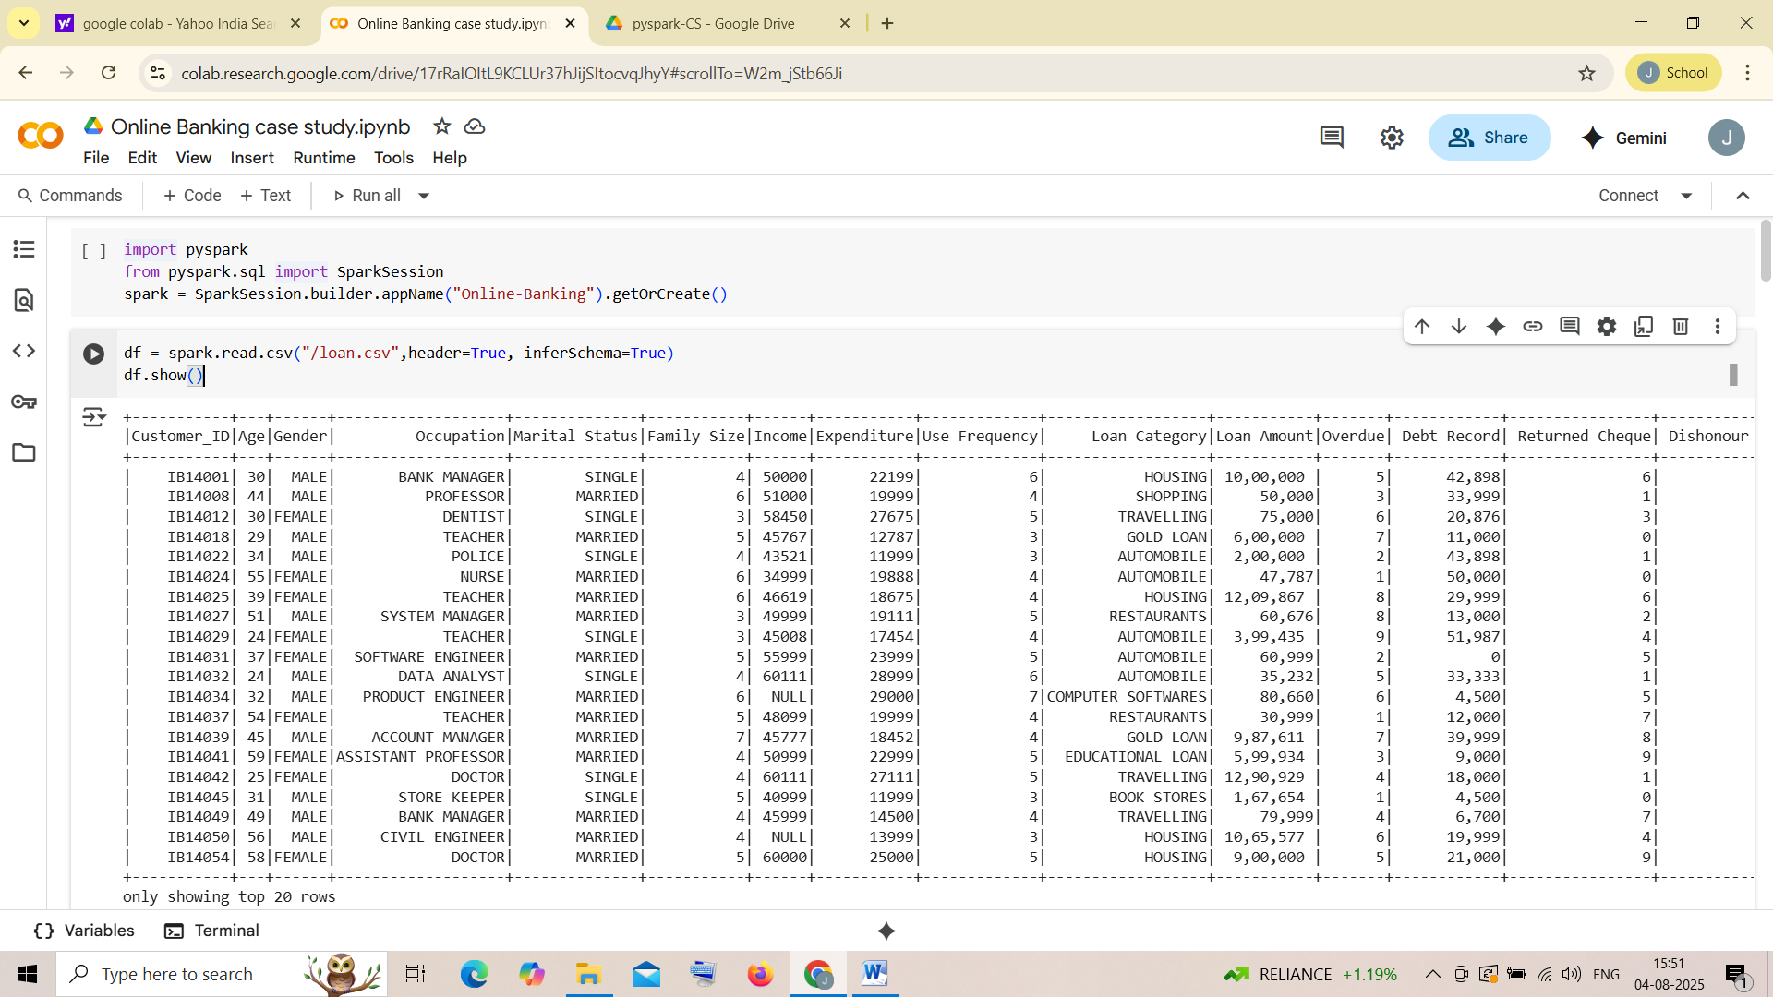

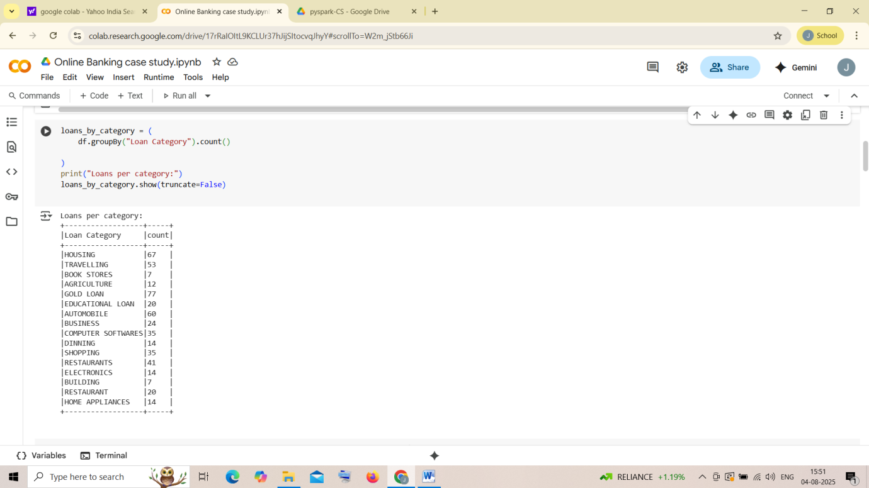

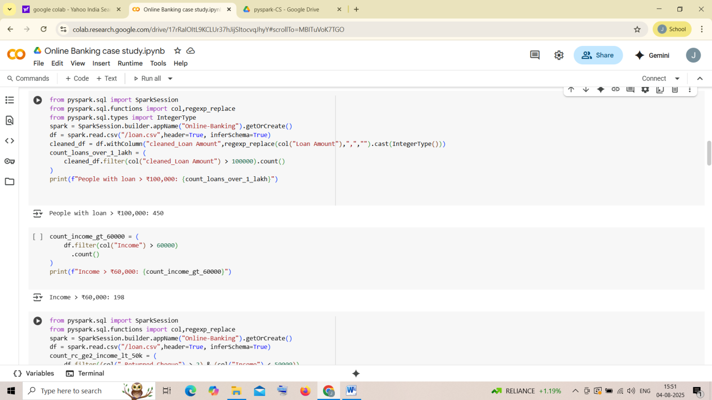

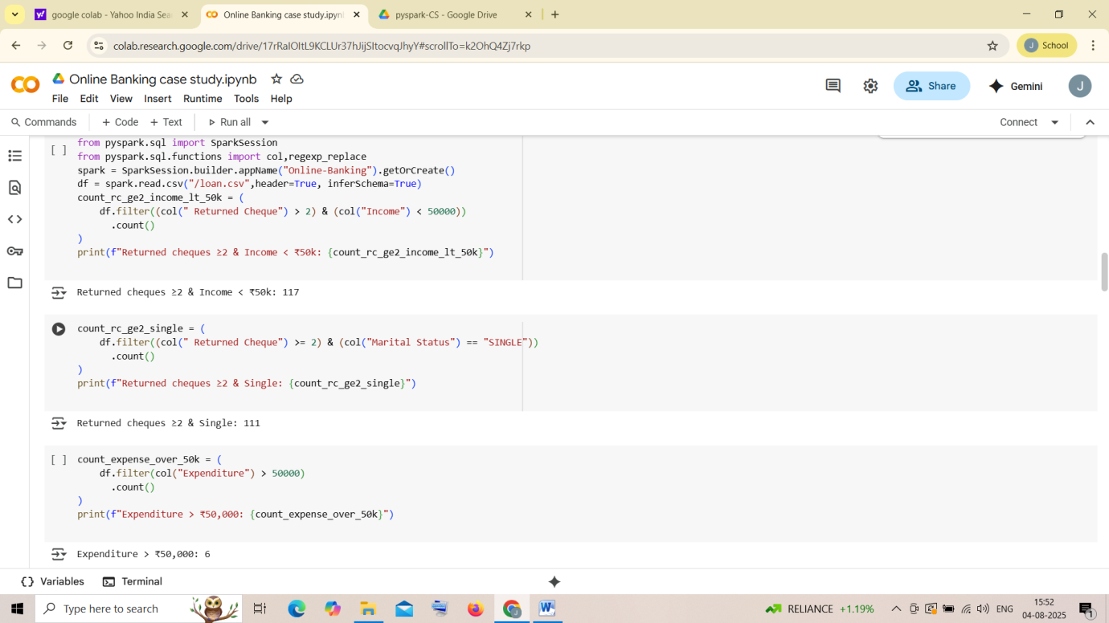

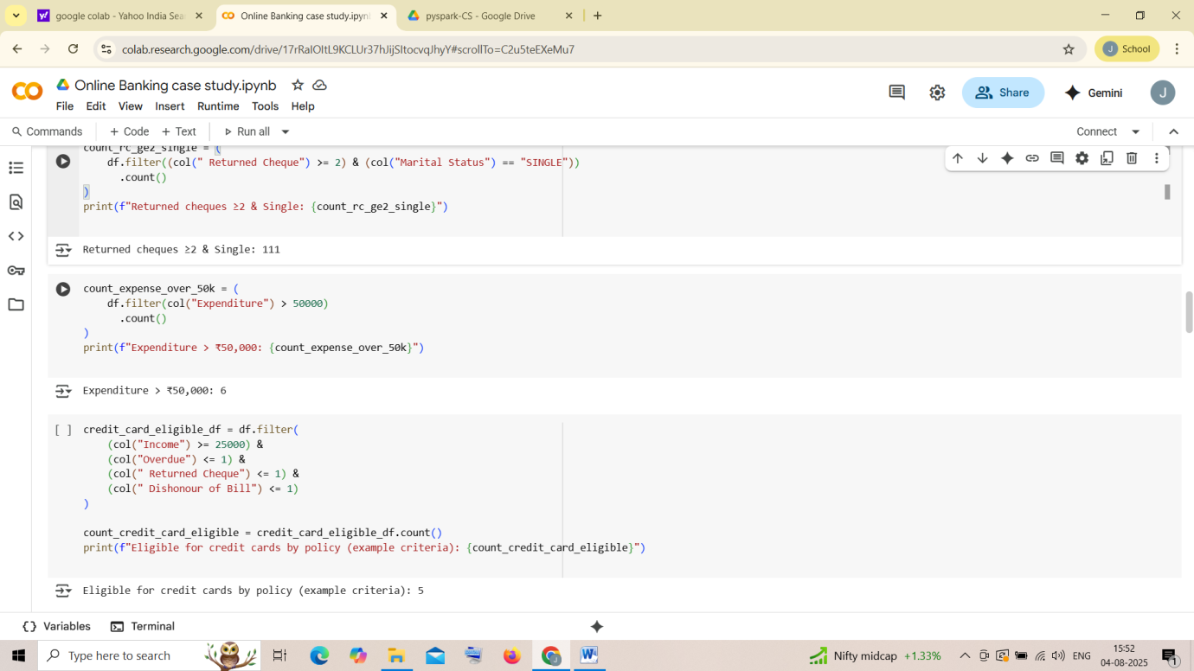

2.

credit card users in Spain

number of members who are elgible and active in the bank

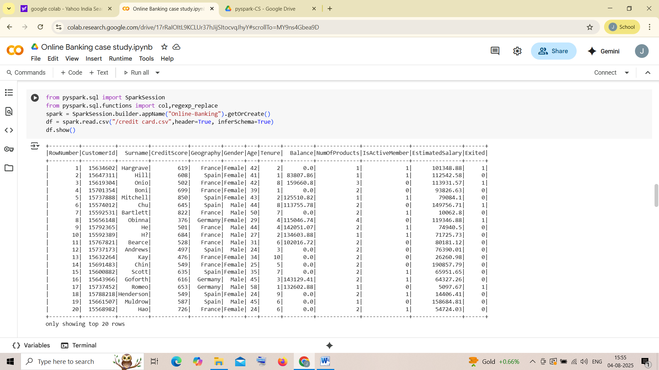

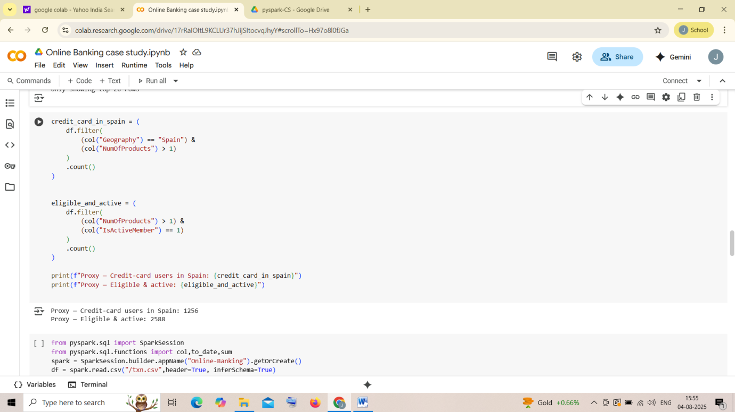

3. Maximum withdrawal amount in transactions

MINIMUM WITHDRAWAL AMOUNT OF AN ACCOUNT in txn.csv

MAXIMUM DEPOSIT AMOUNT OF AN ACCOUNT

MINIMUM DEPOSIT AMOUNT OF AN ACCOUNT

sum of balance in every bank account

Number of transaction on each date

List of customers with withdrawal amount more than 1 lakh

